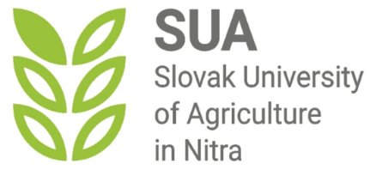

Minutes
Project meeting and practical experience at the Slovak University of Agriculture in Nitra (SUA)
Topic: Green solutions for education, sustainability and ecology in modern society
Date: October 16-17-18, 2023

October 16, 2023
The programme was opened by Mr. Vladislav Valach (Director of International Relations Office of SUA) who welcomed participants of the event and informed them on the detailed programme. Welcome speech was held by the coordinating university in Bijeljina - prof. dr. Boro Krstić. After official opening the programme continued by the presentation of the Nitra municipality Ing. Štefan Lančarič. PhD. – the head of the environment department. The presentation focused on the practical experiences of Nitra municipality in the field of green solutions for education, sustainability and ecology in modern society not just at the municipality level but also in the regional context. After the presentation a fruitful discussion was developed among participants.
The aspect of the same topic was also approached from the university's point of view when participants were provided with a presentation by prof. Zuzana Palková from the Faculty of Engineering of the SUA in Nitra. Prof. Palková presented several international project experiences form the field of Green solutions for Education she actively participated in as coordinator or partner. Participants were very interested in presented topics as well as in the methodology and technical solutions implemented within these projects.
After lunch break the practical tour of the SUA campus was realized with special focus on waste management solutions, Botanical Garden of the university and demonstration of green infrastructure examples.

October 17, 2023

The second day of the practical programme enabled participants of the event the on-site visit of waste management and recycling centre in Nitra. The visit provided beneficial theoretical presentations and practical discussions on thematic topics.
The afternoon´s programme brought participants of the project together in the frame of the project administration and management meeting which was lead by Doc. Dr. Nenad Marković, external expert and consultant of the GROWTH project.

October 18, 2023
As an example of good practice in Green solutions – project participants had a chance to visit an Eco Farm Adam in Podkylava village where they could be part of the presentation of the farm and its production (multifunctional examples of agriculture, processing of fruits…etc.). the visit enabled to see practical implementation of “Green” strategies, policies into practice.

Done in Nitra: 19.10.2023

List of Annexes:

- Annex: Programme of the visit at the SUA in Nitra
- Annex: List of participants
- Annex: Presentations of the event

